**Coding Challenges - PetPals, The Pet Adoption Platform**

**Student name:Sugandan Elangovan**

1. **Provide a SQL script that initializes the database for the Pet Adoption Platform ”PetPals”.**

CREATE DATABASE PetPals;

1. **Create tables for pets, shelters, donations, adoption events, and participants.**
2. **Define appropriate primary keys, foreign keys, and constraints.**
3. **Ensure the script handles potential errors, such as if the database or tables already exist.**

IF NOT EXISTS (SELECT * FROM sys.databases WHERE name = 'PetPals')

BEGIN

CREATE DATABASE PetPals;

END

ELSE

BEGIN

PRINT 'Database already exists.';

END

use PetPals

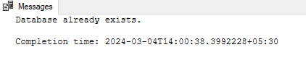

IF NOT EXISTS (SELECT * FROM INFORMATION_SCHEMA.TABLES WHERE TABLE_NAME = 'Shelters')

BEGIN

CREATE TABLE Shelters (

ShelterID INT PRIMARY KEY,

Name VARCHAR(255),

Location VARCHAR(255),

City VARCHAR(255)

);

PRINT 'Table "Shelters" created successfully.';

END

ELSE

BEGIN

PRINT 'Table "Shelters" already exists.';

END

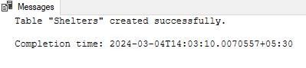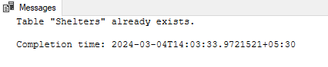

IF NOT EXISTS (SELECT * FROM INFORMATION_SCHEMA.TABLES WHERE TABLE_NAME = 'Donations')

BEGIN

CREATE TABLE Donations (

DonationID INT PRIMARY KEY,

DonorName VARCHAR(255),

DonationType VARCHAR(255),

DonationAmount DECIMAL,

DonationItem VARCHAR(255),

DonationDate DATETIME,

ShelterID INT,

FOREIGN KEY (ShelterID) REFERENCES Shelters(ShelterID)

);

PRINT 'Table "Donations" created successfully.';

END

ELSE

BEGIN

PRINT 'Table "Donations" already exists.';

END

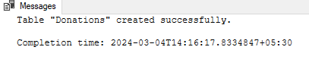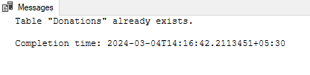

IF NOT EXISTS (SELECT * FROM INFORMATION_SCHEMA.TABLES WHERE TABLE_NAME = 'AdoptionEvents')

BEGIN

CREATE TABLE AdoptionEvents (

EventID INT PRIMARY KEY,

EventName VARCHAR(255),

EventDate DATETIME,

Location VARCHAR(255),

City VARCHAR(255),

OrganizerID INT,

FOREIGN KEY (OrganizerID) REFERENCES Shelters(ShelterID)

);

PRINT 'Table "AdoptionEvents" created successfully.';

END

ELSE

BEGIN

PRINT 'Table "AdoptionEvents" already exists.';

END

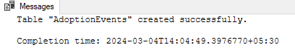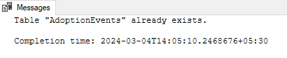

IF NOT EXISTS (SELECT * FROM INFORMATION_SCHEMA.TABLES WHERE TABLE_NAME = 'Participants')

BEGIN

CREATE TABLE Participants (

ParticipantID INT PRIMARY KEY,

ParticipantName VARCHAR(255),

ParticipantType VARCHAR(255),

EventID INT,

FOREIGN KEY (EventID) REFERENCES AdoptionEvents(EventID),

City VARCHAR(255)

);

PRINT 'Table "Participants" created successfully.';

END

ELSE

BEGIN

PRINT 'Table "Participants" already exists.';

END

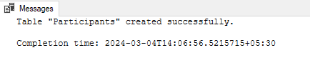

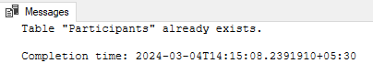

IF NOT EXISTS (SELECT * FROM INFORMATION_SCHEMA.TABLES WHERE TABLE_NAME = 'Pets')

BEGIN

CREATE TABLE Pets (

PetID INT PRIMARY KEY,

Name VARCHAR(255),

Age INT,

Breed VARCHAR(255),

Type VARCHAR(255),

AvailableForAdoption BIT,

ShelterName VARCHAR(255),

OwnerID INT,

ShelterID INT,

FOREIGN KEY (OwnerID) REFERENCES Participants(ParticipantID),

FOREIGN KEY (ShelterID) REFERENCES Shelters(ShelterID)

);

PRINT 'Table "Pets" created successfully.';

END

ELSE

BEGIN

PRINT 'Table "Pets" already exists.';

END

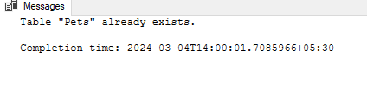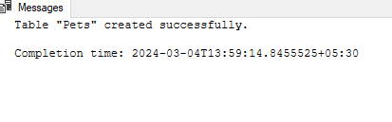

1. **Write an SQL query that retrieves a list of available pets (those marked as available for adoption) from the "Pets" table. Include the pet's name, age, breed, and type in the result set. Ensure that the query filters out pets that are not available for adoption.**

INSERT INTO Shelters (ShelterID, Name, Location, City)

VALUES(1, 'Chennai Pet Shelter', 'Anna Nagar', 'Chennai'),

(2, 'Coimbatore Animal Care', 'Gandhipuram', 'Coimbatore'),

(3, 'Madurai Paws Haven', 'Kochadai', 'Madurai'),

(4, 'Trichy Furry Friends', 'Thillai Nagar', 'Trichy'),

(5, 'Salem Animal Sanctuary', 'Shevapet', 'Salem'),

(6, 'Vellore Pet Haven', 'Gandhi Road', 'Vellore');

INSERT INTO Donations (DonationID, DonorName, DonationType, DonationAmount, DonationItem, DonationDate, ShelterID)

VALUES(1, 'Rajesh Kumar', 'Cash', 500.00, NULL, '2024-03-04 10:30:00', 1),

(2, 'Deepa Sharma', 'Food', NULL, 'Dog Food', '2024-03-05 15:45:00', 2),

(3, 'Suresh Menon', 'Cash', 1000.00, NULL, '2024-03-06 12:15:00', 3),

(4, 'Asha Patel', 'Medicine', NULL, 'Flea Treatment', '2024-03-07 09:00:00', 4),

(5, 'Arjun Rajan', 'Cash', 750.00, NULL, '2024-03-08 14:20:00', 5),

(6, 'Ananya Gupta', 'Toys', NULL, 'Cat Toys', '2024-03-09 17:30:00', 6);

INSERT INTO AdoptionEvents (EventID, EventName, EventDate, Location, City, OrganizerID)

VALUES(1, 'Pet Adoption Day', '2024-03-15 14:00:00', 'VGP Golden Beach', 'Chennai', 1),

(2, 'Furry Friends Fiesta', '2024-03-20 11:30:00', 'Race Course', 'Coimbatore', 2),

(3, 'Paws Parade', '2024-03-25 13:45:00', 'Goripalayam Ground', 'Madurai', 3),

(4, 'Trichy Pet Carnival', '2024-04-02 10:00:00', 'Maris Theater Ground', 'Trichy', 4),

(5, 'Salem Pet Fest', '2024-04-10 15:15:00', 'Anna Park', 'Salem', 5),

(6, 'Vellore Adoption Drive', '2024-04-18 12:30:00', 'VIT University Ground', 'Vellore', 6);

INSERT INTO Participants (ParticipantID, ParticipantName, ParticipantType, EventID, City)

VALUES(1, 'Aruna Nair', 'Volunteer', 1, 'Chennai'),

(2, 'Karthik Raj', 'Adopter', 2, 'Coimbatore'),

(3, 'Meera Devi', 'Volunteer', 3, 'Madurai'),

(4, 'Vijay Kumar', 'Adopter', 4, 'Trichy'),

(5, 'Priya Reddy', 'Volunteer', 5, 'Salem'),

(6, 'Gopal Krishnan', 'Adopter', 6, 'Vellore');

INSERT INTO Pets (PetID, Name, Age, Breed, Type, AvailableForAdoption, ShelterName, OwnerID, ShelterID)

VALUES(1, 'Charlie', 2, 'Labrador Retriever', 'Dog', 1, 'Chennai Pet Shelter', NULL, 1),

(2, 'Whiskers', 1, 'Siamese', 'Cat', 1, 'Coimbatore Animal Care', NULL, 2),

(3, 'Rocky', 3, 'German Shepherd', 'Dog', 1, 'Madurai Paws Haven', NULL, 3),

(4, 'Mittens', 2, 'Persian', 'Cat', 1, 'Trichy Furry Friends', NULL, 4),

(5, 'Buddy', 1, 'Golden Retriever', 'Dog', 1, 'Salem Animal Sanctuary', NULL, 5),

(6, 'Fluffy', 2, 'Ragdoll', 'Cat', 1, 'Vellore Pet Haven', NULL, 6);

SELECT Name, Age, Breed, Type FROM Pets WHERE AvailableForAdoption = 1;

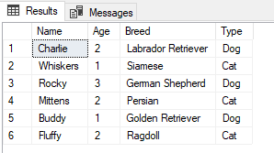

1. **Write an SQL query that retrieves the names of participants (shelters and adopters) registered for a specific adoption event. Use a parameter to specify the event ID. Ensure that the query joins the necessary tables to retrieve the participant names and types.**

SELECT Participants.ParticipantName, Participants.ParticipantType

FROM Participants

JOIN AdoptionEvents ON Participants.EventID = AdoptionEvents.EventID

WHERE AdoptionEvents.EventName = 'Pet Adoption Day';

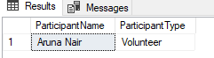

1. **Create a stored procedure in SQL that allows a shelter to update its information (name and location) in the "Shelters" table. Use parameters to pass the shelter ID and the new information. Ensure that the procedure performs the update and handles potential errors, such as an invalid shelter ID.**

CREATE PROCEDURE UpdateShelterInfo

@ShelterID INT,

@NewName VARCHAR(255),

@NewLocation VARCHAR(255)

AS

BEGIN

SET NOCOUNT ON;

IF NOT EXISTS (SELECT 1 FROM Shelters WHERE ShelterID = @ShelterID)

BEGIN

PRINT 'Error: ShelterID does not exist.';

RETURN;

END

UPDATE Shelters

SET Name = @NewName,

Location = @NewLocation

WHERE ShelterID = @ShelterID;

PRINT 'Shelter information updated successfully.';

END;

EXEC UpdateShelterInfo @ShelterID = 1, @NewName = 'Fullfy Friends', @NewLocation = 'Perungalathur';

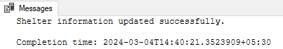

1. **Write an SQL query that calculates and retrieves the total donation amount for each shelter (by shelter name) from the "Donations" table. The result should include the shelter name and the total donation amount. Ensure that the query handles cases where a shelter has received no donations.**

SELECT S.Name AS ShelterName, COALESCE(SUM(D.DonationAmount), 0) AS TotalDonationAmount FROM

Shelters S LEFT JOIN Donations D ON S.ShelterID = D.ShelterID GROUP BY S.Name;

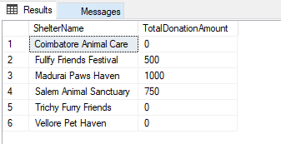

1. **Write an SQL query that retrieves the names of pets from the "Pets" table that do not have an owner (i.e., where "OwnerID" is null). Include the pet's name, age, breed, and type in the result set.**

SELECT Name, Age, Breed, Type FROM Pets WHERE OwnerID IS NULL;

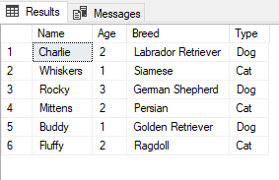

1. **Write an SQL query that retrieves the total donation amount for each month and year (e.g., January 2023) from the "Donations" table. The result should include the month-year and the corresponding total donation amount. Ensure that the query handles cases where no donations were made in a specific month-year.**

SELECT FORMAT(DonationDate, 'MMMM yyyy') AS MonthYear, COALESCE(SUM(DonationAmount), 0) AS

TotalDonationAmount FROM Donations GROUP BY FORMAT(DonationDate, 'MMMM yyyy');

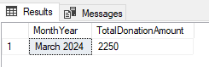

1. **Retrieve a list of distinct breeds for all pets that are either aged between 1 and 3 years or older than 5 years.**

SELECT DISTINCT Breed FROM Pets WHERE (Age BETWEEN 1 AND 3) OR (Age > 5);

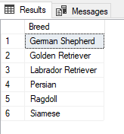

1. **Retrieve a list of pets and their respective shelters where the pets are currently available for adoption.**

SELECT P.Name AS PetName, P.Age, P.Breed, P.Type, S.Name AS ShelterName

FROM Pets P JOIN Shelters S ON P.ShelterName = S.Name WHERE P.AvailableForAdoption = 1;

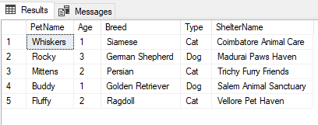

1. **Find the total number of participants in events organized by shelters located in specific city. Example: City=Chennai**

SELECT S.Name AS ShelterName,COUNT(P.ParticipantID) AS TotalParticipants

FROM Participants P JOIN AdoptionEvents AE ON P.EventID = AE.EventID

JOIN Shelters S ON AE.OrganizerID = S.ShelterID WHERE S.City = 'Chennai' GROUP BY S.Name;

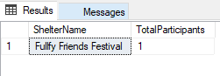

1. **Retrieve a list of unique breeds for pets with ages between 1 and 5 years.**

SELECT DISTINCT Breed FROM Pets WHERE Age BETWEEN 1 AND 5;

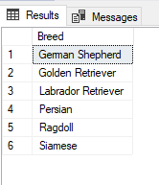

1. **Find the pets that have not been adopted by selecting their information from the 'Pet' table.**

SELECT * FROM Pets WHERE OwnerID IS NULL;

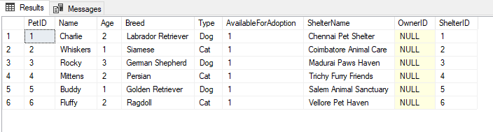

1. **Retrieve the names of all adopted pets along with the adopter's name from the 'Adoption' and 'User' tables.**

CREATE TABLE Adoptions (

AdoptionID INT PRIMARY KEY,

AdopterName VARCHAR(255),

PetID INT,

AdoptionDate DATETIME,

FOREIGN KEY (PetID) REFERENCES Pets(PetID)

);

CREATE TABLE Users (

UserID INT PRIMARY KEY,

UserName VARCHAR(255) NOT NULL,

Email VARCHAR(255) UNIQUE NOT NULL,

DateOfBirth DATE,

RegistrationDate DATETIME DEFAULT CURRENT_TIMESTAMP

);

INSERT INTO Users (UserID, UserName, Email, DateOfBirth, RegistrationDate)

VALUES

(1, 'Arvind Kumar', 'arvind.kumar@example.com', '1985-05-10', '2024-03-04 08:30:00'),

(2, 'Priya Devi', 'priya.devi@example.com', '1990-08-15', '2024-03-04 09:45:00'),

(3, 'Karthik Rajan', 'karthik.rajan@example.com', '1988-11-22', '2024-03-04 11:15:00'),

(4, 'Sangeetha Ramesh', 'sangeetha.ramesh@example.com', '1995-03-18', '2024-03-04 13:30:00'),

(5, 'Anand Kumar', 'anand.kumar@example.com', '1980-07-01', '2024-03-04 15:00:00'),

(6, 'Deepika Mani', 'deepika.mani@example.com', '1993-12-05', '2024-03-04 16:45:00');

INSERT INTO Adoptions (AdoptionID, AdopterName, PetID, AdoptionDate)

VALUES

(1, 'Arvind Kumar', 1, '2024-03-05 10:00:00'),

(2, 'Priya Devi', 2, '2024-03-06 11:30:00'),

(3, 'Karthik Rajan', 3, '2024-03-07 12:45:00'),

(4, 'Sangeetha Ramesh', 4, '2024-03-08 14:15:00'),

(5, 'Anand Kumar', 5, '2024-03-09 16:00:00'),

(6, 'Deepika Mani', 6, '2024-03-10 17:30:00');

SELECT P.Name AS PetName, U.UserName AS AdopterName FROM Adoptions A

JOIN Pets P ON A.PetID = P.PetID JOIN Users U ON A.AdoptionID = U.UserID;

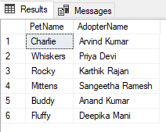

1. **Retrieve a list of all shelters along with the count of pets currently available for adoption in each shelter.**

SELECT S.Name AS ShelterName, COUNT(P.PetID) AS PetsAvailableForAdoption FROM Shelters S

LEFT JOIN Pets P ON S.ShelterID = P.ShelterID AND P.AvailableForAdoption = 1 GROUP BY S.ShelterID, S.Name;

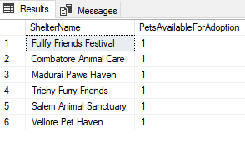

1. **Find pairs of pets from the same shelter that have the same breed.**

INSERT INTO Pets (PetID, Name, Age, Breed, Type, AvailableForAdoption, ShelterName, OwnerID, ShelterID)

VALUES(7, 'Goldy', 2, 'Labrador Retriever', 'Dog', 1, 'Chennai Pet Shelter', NULL, 1),

(8, 'Fluffs', 1, 'Siamese', 'Cat', 1, 'Coimbatore Animal Care', NULL, 2);

SELECT A.PetID AS Pet1ID, B.PetID AS Pet2ID, A.Breed AS SharedBreed, A.ShelterID AS ShelterID

FROM Pets A JOIN Pets B ON A.ShelterID = B.ShelterID AND A.PetID < B.PetID WHERE A.Breed = B.Breed;

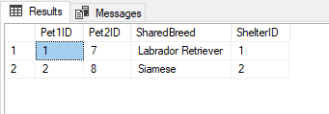

1. **List all possible combinations of shelters and adoption events.**

SELECT S.ShelterID AS ShelterID, S.Name AS ShelterName, AE.EventID AS EventID,

AE.EventName AS EventName FROM Shelters S CROSS JOIN AdoptionEvents AE;

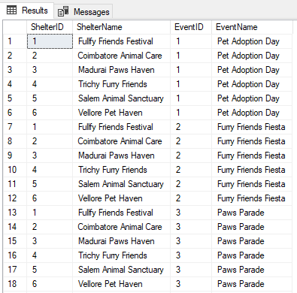

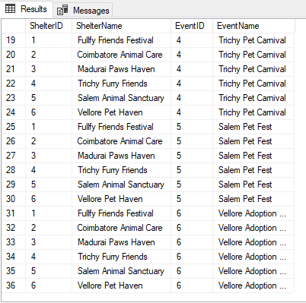

1. **Determine the shelter that has the highest number of adopted pets.**

SELECT TOP 1 S.ShelterID, S.Name AS ShelterName, COUNT(A.PetID) AS AdoptedPetsCount

FROM Shelters S JOIN Pets A ON S.ShelterID = A.ShelterID GROUP BY S.ShelterID, S.Name ORDER BY AdoptedPetsCount DESC;

